Math 8 Application 1 Name ________________________
Show all your work!

1. Circle the letter that represents the approximate location on the number line of $\sqrt{13}$.  A B C D  0 5 10 15 | 2. Simplify without a negative exponent:  4⁻² = | 3. Solve for x:  x² = 81
4. Write in scientific notation.  0.000945 | 5. Write the product in scientific notation.  (4.2 ∙ 10³)(3 ∙ 10⁵) = | 6. Solve for x.  2x – 15 = 5x + 7
7. What type of transformations of Figure A resulted in Figure B?  A  B | 8. Find the length of side a below.  a 15 in.  12 in. | 9. Find the measure of angle b.  37◦  b
10. Put the following rational numbers in order from smallest to largest.  ⅞, ⅖, .27, .78 | 11. Estimate the quotient below.  73,951 ÷ 925 | 12. Write as a fraction in simplest form: .3333….
13. Write an equation for the function.  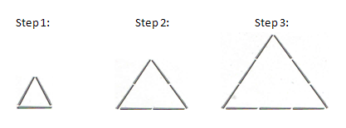 | 14. Graph the first nine steps.  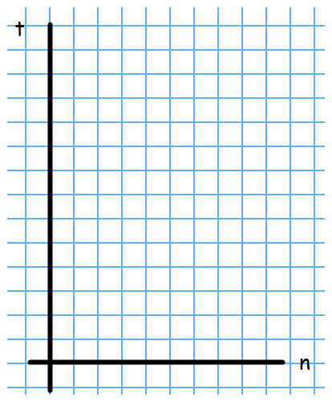 | 15. Complete the table.
  Step Number | Total Toothpicks
  0
  1
  2
  20
  50
  100
16. What is the sale price of a pair of $40 jeans that is marked 30% off? | 17. Find the volume of a cylinder with a radius of 6 m and a height of 3 m. | 18. A centipede traveled 1200 cm in 5 hours. What was the rate of speed in cm per hour?
19. Juan’s quiz scores are 7, 8, 5, 9, and 10. What is the mean of his quizzes? | 20. Sara ran 800 meters and then walked 1200 meters. How many kilometers did she travel? | Number correct  5 minutes_______  Total___________

